**Week 2 Assignment: Exploring HTML Tags**

**Objectives:**

The primary objectives of this assignment are:

To understand the usage of the <hr> and <font> tags in HTML.

To apply different attributes within these tags to control their appearance.

To explore the size, width, and color attributes in the <hr> tag.

To experiment with the size, color, and face attributes in the <font> tag.

To differentiate between absolute and relative size values when using the size attribute in the <font> tag.

**Technology Used:**

Since this assignment focuses on fundamental HTML concepts, the following tools and technologies are used:

HTML (HyperText Markup Language) – for structuring content.

Text Editors such as Notepad++, Sublime Text, or VS Code – for writing the HTML code.

Web Browsers like Google Chrome, Mozilla Firefox, or Microsoft Edge – for viewing the output.

**Implementation Details:**

The <hr> tag will be used with the size, width, and color attributes to define horizontal lines with varying thickness, width, and color.

The <font> tag will be utilized with the size, color, and face attributes to style text with different colors, sizes, and fonts.

The size attribute in the <font> tag will be demonstrated using both absolute values (e.g., 5px) and relative values (e.g., 50%, 70%).

**Source Code:**

<!DOCTYPE html>

<html>

<head>

<title>The Bishop's Candlestick</title>

</head>

<body>

<center><h1>The Bishop's Candlestick</h1></center>

<hr size="1px" width="80%" color="brown">

<br>

<center>

[Marie and Persome discovered. Marie stirring some soup on the fire. Persome laying

the cloth, etc.]

<br>

<font color="DarkMagenta"><b>Persome:</b></font> Marie, isn’t the soup boiling yet?<br> <br>

<font color="DarkBlue"><b>Marie:</b></font> Not yet, madam.<br> <br>

<font color="DarkMagenta"><b>Persome:</b></font> Well, it ought to be. You haven’t tended the fire properly, child.<br> <br>

<font color="DarkBlue"><b>Marie:</b></font> But, madam, you yourself made the fire up.<br> <br>

<font color="DarkMagenta"><b>Persome:</b></font> Don’t answer me back like that. It is rude.<br> <br>

<font color="DarkBlue"><b>Marie:</b></font> Yes, madam.<br> <br>

<font color="DarkMagenta"><b>Persome:</b></font> Then don’t let me have to rebuke you again.<br> <br>

<font color="DarkBlue"><b>Marie:</b></font> No, madam.<br> <br>

<font color="DarkMagenta"><b>Persome:</b></font> I wonder where my brother can be. <i>(Looking at the clock.)</i> It is after eleven o’clock and no sign of him. Marie!<br><br>

<font color="DarkBlue"><b>Marie:</b></font> Yes, madam.<br><br>

<font color="DarkMagenta"><b>Persome:</b></font> Did Monseigneur the Bishop leave any message for me?<br><br>

<font color="DarkBlue"><b>Marie:</b></font> No, madam.<br><br>

<font color="DarkMagenta"><b>Persome:</b></font> Did he tell you where he was going?<br><br>

<font color="DarkBlue"><b>Marie:</b></font> Yes, madam.<br><br>

<font color="DarkMagenta"><b>Persome:</b></font> <i>(Imitating)</i> "Yes, madam." Then why haven’t you told me, stupid!<br><br>

<font color="DarkBlue"><b>Marie:</b></font> Madam didn’t ask me.<br><br>

<font color="DarkMagenta"><b>Persome:</b></font> But that is no reason for you not telling me, is it?<br><br>

<font color="DarkBlue"><b>Marie:</b></font> Madam said only this morning I was not to chatter, so I thought...<br><br>

<font color="DarkMagenta"><b>Persome:</b></font> Ah, Mon Dieu! You thought! Ah! It is hopeless.<br><br>

<font color="DarkBlue"><b>Marie:</b></font> Yes, madam.<br><br>

<b><font color="DarkMagenta">Persome:</font></b> Don’t keep saying ‘Yes, Madam’ like a parrot, nincompoop!<br><br>

<b><font color="DarkBlue">Marie:</font></b> No, madam.<br><br>

<b><font color="DarkMagenta">Persome:</font></b> Well. Where did Monseigneur say he was going?<br><br>

<b><font color="DarkBlue">Marie:</font></b> To my mother’s, madam.<br><br>

<b><font color="DarkMagenta">Persome:</font></b> To your mother’s indeed! And why, pray?<br><br>

<b><font color="DarkBlue">Marie:</font></b> Monseigneur asked me how she was, and I told him she was feeling poorly.<br><br>

<b><font color="DarkMagenta">Persome:</font></b> You told him she was feeling poorly, did you? And so my brother is to be kept out of his bed, and go without his supper because you told him she was feeling poorly. There’s gratitude for you!<br><br>

<b><font color="DarkBlue">Marie:</font></b> Madam, the soup is boiling!<br><br>

<b><font color="DarkMagenta">Persome:</font></b> Then pour it out, fool, and don’t chatter. <i>(Marie about to do so.)</i> No, no, not like that. Here, let me do it, and did you put the salt-cellars on the table—the silver ones?<br><br>

<b><font color="DarkBlue">Marie:</font></b> The silver ones, madam?<br><br>

<b><font color="DarkMagenta">Persome:</font></b> Yes, the silver ones. Are you deaf as well as stupid?<br><br>

<b><font color="DarkBlue">Marie:</font></b> They are sold, madam.<br><br>

<b><font color="DarkMagenta">Persome:</font></b> <i>(with horror)</i> Sold! Are you mad? Who sold them? Why were they sold?<br><br>

<b><font color="DarkBlue">Marie:</font></b> Monseigneur the Bishop told me this afternoon, while you were out, to take them to Monseigneur Gervais, who has often admired them, and sell them for as much as I could.<br><br>

<b><font color="DarkMagenta">Persome:</font></b> But you had no right to do so without asking me.<br><br>

<b><font color="DarkBlue">Marie:</font></b> <i>(with awe)</i> But, madam, Monseigneur the Bishop told me.<br><br>

<b><font color="DarkMagenta">Persome:</font></b> Monseigneur the Bishop is a-ahem! But-but what can he have wanted with the money!<br><br>

<b><font color="DarkBlue">Marie:</font></b> Pardon, madam, but I think it was for Mere Gringoire.<br><br>

<b><font color="DarkMagenta">Persome:</font></b> Mere Gringoire indeed! Mere Gringoire! What, the old witch who lives at the top of the hill, and who says she is bedridden because she is too lazy to do any work? And what did Mere Gringoire want with the money, pray?<br><br>

<b><font color="DarkBlue">Marie:</font></b> Madam, it was for the rent. The bailiff would not wait any longer, and threatened to turn her out today if it were not paid, so she sent little Jean to Monseigneur to ask for help, and—<br><br>

<b><font color="DarkMagenta">Persome:</font></b> Oh, <i>mon Dieu!</i> It is hopeless, hopeless. We shall have nothing left. His estate is sold, his savings have gone. His furniture, everything. Were it not for my little dot we should starve! And now my beautiful—beautiful <i>(sobs)</i> salt-cellars. Ah, it is too much, too much. <i>(She breaks down crying.)</i><br><br>

<b><font color="DarkBlue">Marie:</font></b> Madam, I am sorry, if I had known—<br><br>

<b><font color="DarkMagenta">Persome:</font></b> Sorry, and why pray? If Monseigneur the Bishop chooses to sell his salt-cellars he may do so, I suppose. Go and wash your hands, they are disgracefully dirty.<br><br>

<b><font color="DarkBlue">Marie:</font></b> Yes, madam. <i>(going towards R.)</i><br><br>

<br>

<center><i>[Enter the Bishop,C.]</i></center>

<br>

<b><font color="green">Bishop:</font></b> Ah! How nice and warm it is in here! It is worth going out in the cold for the sake of the comfort of coming in.<br><br>

<i>[Persome has hastened to help him off with his coat etc. Marie has dropped a deep courtesy.]</i><br><br>

<b><font color="green">Bishop:</font></b> Thank you, dear. <i>(Looking at her.)</i> Why, what is the matter? You have been crying. Has Marie been troublesome, eh? <i>(shaking his finger at her)</i> Ah!<br><br>

<b><font color="DarkMagenta">Persome:</font></b> No, it wasn’t Marie—but—but—<br><br>

<b><font color="green">Bishop:</font></b> Well, well, you shall tell me presently! Marie, my child, run home now; your mother is better. I have prayed with her, and the doctor has been. Run home! <i>(Marie putting on cloak and going.)</i> And, Marie, let yourself in quietly in case your mother is asleep.<br><br>

<b><font color="DarkBlue">Marie:</font></b> Oh, thanks, thanks, Monseigneur.<br><br>

<i>[She goes to door C.; as it opens the snow drives in.]</i><br><br>

<b><font color="green">Bishop:</font></b> Here, Marie, take my comforter, it will keep you warm. It is very cold tonight.<br><br>

<b><font color="DarkBlue">Marie:</font></b> Oh, no Monseigneur! <i>(shamefacedly)</i>.<br><br>

<b><font color="DarkMagenta">Persome:</font></b> What nonsense, brother, she is young, she won’t hurt.<br><br>

<b><font color="green">Bishop:</font></b> Ah, Persome, you have not been out, you don’t know how cold it has become. Here, Marie, let me put it on for you. <i>(Does so)</i> There! Run along, little one.<br><br>

<i>[Exit Marie, C.]</i><br>

<b><font color="DarkMagenta">Persome:</font></b> Brother, I have no patience with you. There, sit down and take your soup, it has been waiting ever so long. And if it is spoilt, it serves you right.<br><br>

<b><font color="green">Bishop:</font></b> It smells delicious.<br>

<b><font color="DarkMagenta">Persome:</font></b> I’m sure Marie’s mother is not so ill that you need have stayed out on such a night as this. I believe those people pretend to be ill just to have the Bishop call on them. They have no thought of the Bishop!<br><br>

<b><font color="green">Bishop:</font></b> It is kind of them to want to see me.<br><br>

<b><font color="DarkMagenta">Persome:</font></b> Well, for my part, I believe that charity begins at home.<br><br>

<b><font color="green">Bishop:</font></b> And so you make me this delicious soup. You are very good to me, sister.<br><br>

<b><font color="DarkMagenta">Persome:</font></b> Good to you, yes! I should think so. I should like to know where you would be without me to look after you. The dupe of every idle scamp or lying old woman in the parish!<br><br>

<b><font color="green">Bishop:</font></b> If people lie to me, they are poorer, not I.<br><br>

<b><font color="DarkMagenta">Persome:</font></b> But it is ridiculous; you will soon have nothing left. You give away everything, <u>everything!!!</u><br><br>

<b><font color="green">Bishop:</font></b> My dear, there is so much suffering in the world, and I can do so little <i>(sighs)</i>, so very little.<br><br>

<b><font color="DarkMagenta">Persome:</font></b> Suffering, yes; but you never think of the suffering you cause to those who love you best, the suffering you cause to me.<br><br>

<b><font color="green">Bishop:</font></b> <i>(rising)</i> You, sister dear? Have I hurt you? Ah, I remember you had been crying. Was it my fault? I didn’t mean to hurt you. I am sorry.<br><br>

<b><font color="DarkMagenta">Persome:</font></b> Sorry. Yes. Sorry won’t mend it. <i>Humph!</i> Oh, do go on eating your soup before it gets cold.<br><br>

<b><font color="green">Bishop:</font></b> Very well, dear. <i>(Sits.)</i> But tell me—<br><br>

<b><font color="DarkMagenta">Persome:</font></b> You are like a child. I can’t trust you out of my sight. No sooner is my back turned than you get that little minx Marie to sell the silver salt-cellars.<br><br>

<b><font color="green">Bishop:</font></b> Ah, yes, the salt-cellars. It is a pity. You—you were proud of them?<br><br>

<b><font color="DarkMagenta">Persome:</font></b> <u>Proud of them?</u> Why, they have been in our family for years.<br><br>

<b><font color="green">Bishop:</font></b> Yes, it is a pity. They were beautiful; but still, dear, one can eat salt out of china just as well.<br><br>

<b><font color="DarkMagenta">Persome:</font></b> Yes, or meat off the floor, I suppose. Oh, it’s coming to that. And as for that old wretch, Mere Gringoire, I wonder she had the audacity to send here again. The last time I saw her I gave her such a talking to that it ought to have had some effect.<br><br>

<b><font color="green">Bishop:</font></b> Yes! I offered to take her in here for a day or two, but she seemed to think it might distress you.<br><br>

<b><font color="DarkMagenta">Persome:</font></b> <u>Distress me!!!</u><br><br>

<b><font color="green">Bishop:</font></b> And the bailiff, who is a very just man, would not wait longer for the rent, so—so—you see I had to pay it.<br><br>

<b><font color="DarkMagenta">Persome:</font></b> <i>(Gesture of comic despair.)</i> You had to pay it.<br><br>

<br>

<b><font color="green">Bishop:</font></b> Yes, and you see I had no money, so I had to dispose of the salt-cellars. It was fortunate I had them, wasn’t it? <i>(Smiling)</i> But I’m sorry, I have grieved you.<br><br>

<b><font color="DarkMagenta">Persome:</font></b> Oh, go on! Go on! You are incorrigible. You’ll sell your candlesticks next.<br><br>

<b><font color="green">Bishop:</font></b> <i>(With real concern)</i> No, no, sister, not my candlesticks.<br><br>

<b><font color="DarkMagenta">Persome:</font></b> Oh! Why not? They would pay somebody’s rent, I suppose.<br><br>

<b><font color="green">Bishop:</font></b> Ah, you are good, sister, to think of that; but-but I don’t want to sell them. You see, dear, my mother gave them to me on-on her death-bed just after you were born, and—and she asked me to keep them in remembrance of her, so I would like to keep them; but perhaps it is a sin to set such store by them?<br><br>

<b><font color="DarkMagenta">Persome:</font></b> Brother, brother, you will break my heart <i>(with tears in her voice)</i>. There! Don’t say anything more. Kiss me and give me your blessing. I’m going to bed.<br><br>

<i>(He blesses her.)</i><br>

<i>[Bishop makes the sign of the Cross and murmurs a blessing. Persome locks up the cupboard door and goes R.]</i><br><br>

<b><font color="DarkMagenta">Persome:</font></b> Don’t sit up too long and tire your eyes.<br><br>

<b><font color="green">Bishop:</font></b> No, dear! Good night!<br><br>

<i>[Persome exits R.]</i><br>

<i>[Bishop comes to table and opens a book, then looks up at the candlesticks.]</i><br><br>

<b><font color="green">Bishop:</font></b> They would pay somebody’s rent. It was kind of her to think of that.<br><br>

<i>[He stirs the fire, trims the lamp, arranges some books and papers, sits down, is restless, shivers slightly; the clock outside strikes twelve and he settles down to read.]</i><br><br>

<i>[Music during this. Enter a Convict stealthily; he has a long knife and seizes the Bishop from behind.]</i><br><br>

<b><font color="Brown">Convict:</font></b> If you call out, you are a dead man!<br><br>

<b><font color="green">Bishop:</font></b> But, my friend, as you see, I am reading. Why should I call out? Can I help you in any way?<br><br>

<b><font color="Brown">Convict:</font></b> <i>(Hoarsely)</i> I want food. I’m starving, I haven’t eaten anything for three days. Give me food quickly, quickly, curse you!<br><br>

<b><font color="green">Bishop:</font></b> <i>(Eagerly)</i> But certainly, my son, you shall have food. I will ask my sister for the keys of the cupboard. <i>(Rising.)</i><br><br>

<b><font color="Brown">Convict:</font></b> Sit down!!!<br><br>

<i>(The Bishop sits, smiling.)</i><br>

<b><font color="Brown">Convict:</font></b> None of that, my friend! I’m too old a bird to be caught with chaff. You would ask your sister for the keys, would you? A likely story! You would rouse the house too. Eh? Ha! ha! A good joke truly. Come, where is the food? I want no keys. I have a wolf inside me tearing at my entrails, tearing me; quick, tell me, where the food is?<br><br>

<b><font color="green">Bishop (aside):</font></b> I wish Persome would not lock the cupboard. <i>(Aloud)</i> Come, my friend, you have nothing to fear. My sister and I are alone here.<br><br>

<b><font color="Brown">Convict:</font></b> How do I know that?<br><br>

<b><font color="Purple">Bishop:</font></b> Why, I have just told you.<br><br>

<i>[Convict looks long at the Bishop.]</i><br><br>

<b><font color="Brown">Convict:</font></b> Humph! I’ll risk it. <i>(Bishop, going to door R.)</i> But mind! Play me false, and as sure as there are devils in hell, I’ll drive my knife through your heart. I have nothing to lose.<br><br>

<b><font color="green">Bishop:</font></b> You have your soul to lose, my son; it is of more value than my heart. <i>(At door R., calling.)</i> Persome! Persome!<br><br>

<i>[The Convict stands behind him, with his knife ready.]</i><br><br>

<b><font color="DarkMagenta">Persome (within):</font></b> Yes, brother.<br><br>

<b><font color="green">Bishop:</font></b> Here is a poor traveller who is hungry. If you have not settled as yet, will you come and open the cupboard and I will give him some supper?<br><br>

<b><font color="DarkMagenta">Persome (within):</font></b> What, at this time of night? A pretty business truly. Are we to have no sleep now, but to be at the beck and call of every ne’er-do-well who happens to pass?<br><br>

<b><font color="Purple">Bishop:</font></b> But, Persome, the traveller is hungry.<br><br>

<b><font color="DarkMagenta">Persome:</font></b> Oh, very well. I am coming. <i>(Persome enters R. She sees the knife in the Convict’s hand.)</i> <i>(Frightened)</i> Brother, what is he doing with that knife?<br><br>

<b><font color="green">Bishop:</font></b> The knife-oh, well, you see, dear, perhaps he may have thought that I-I had sold ours. <i>[Laughs gently.]</i><br>

<b><font color="DarkMagenta">Persome:</font></b> Brother, I am frightened. He glares at us like a wild beast. <i>(Aside to him.)</i><br><br>

<b><font color="Brown">Convict:</font></b> Hurry, I tell you. Give me food or I’ll stick my knife in you both and help myself.<br><br>

<b><font color="green">Bishop:</font></b> Give me the keys, Persome.<br><br>

<i>(She gives the keys to him.)</i><br>

<b><font color="green">Bishop:</font></b> And now, dear, you may go to bed.<br><br>

<i>[Persome going. The Convict springs in front of her.]</i><br><br>

<b><font color="Brown">Convict:</font></b> Stop! Neither of you shall leave this room till I do.<br><br>

<i>[She looks at the Bishop.]</i><br>

<b><font color="green">Bishop:</font></b> Persome, will you favour this gentleman with your company at supper? He evidently desires it.<br><br>

<b><font color="DarkMagenta">Persome:</font></b> Very well, brother.<br><br>

<i>[She sits down at the table staring at the two.]</i><br><br>

<b><font color="green">Bishop:</font></b> Here is some cold pie and a bottle of wine and some bread.<br><br>

<b><font color="Brown">Convict:</font></b> Put them on the table, and stand behind it so that I can see you.<br><br>

<i>[Bishop does so and opens drawer in table, taking out knife and fork, looking at the knife in Convict’s hand.]</i><br><br>

<b><font color="Brown">Convict:</font></b> My knife is sharp. <i>(He runs his finger along the edge and looks at them meaningfully.)</i> And as for forks… <i>(taking it up) (laughs)</i> Steel! <i>(He throws it away.)</i> We don’t use forks in prison.<br><br>

<b><font color="DarkMagenta">Persome:</font></b> Prison?<br><br>

<b><font color="Brown">Convict:</font></b> <i>(Cutting off an enormous slice from the pie, he tears it with his fingers like an animal. Then starts.)</i> What was that? <i>(He looks at the door.)</i> Why the devil do you leave the window unshuttered and the door unbarred so that anyone can come in? <i>(shutting them.)</i><br><br>

<b><font color="green">Bishop:</font></b> That is why they are left open.<br><br>

<b><font color="Brown">Convict:</font></b> Well, they are shut now!<br><br>

<b><font color="green">Bishop (sighs):</font></b> For the first time in thirty years.<br><br>

<i>[Convict eats voraciously and throws a bone on the floor.]</i><br><br>

<b><font color="DarkMagenta">Persome:</font></b> Oh, my nice clean floor!<br><br>

<i>[Bishop picks up the bone and puts it on plate.]</i><br><br>

<b><font color="Brown">Convict:</font></b> You’re not afraid of thieves?<br><br>

<b><font color="green">Bishop:</font></b> I am sorry for them.<br><br>

<b><font color="Brown">Convict:</font></b> Sorry for them. Ha! Ha! Ha! <i>(Drinks from bottle.)</i> That’s a good one. Sorry for them. Ha! Ha! Ha! <i>(Drinks again.)</i> <br><br>

<i>(suddenly)</i> Who the devil are you?<br><br>

<b><font color="green">Bishop:</font></b> I am a Bishop.<br><br>

<b><font color="Brown">Convict:</font></b> Ha! Ha! Ha! A Bishop! Holy Virgin, a Bishop.<br><br>

<b><font color="green">Bishop:</font></b> I hope you may escape that, my son. Persome, you may leave us; this gentleman will excuse you.<br><br>

<b><font color="DarkMagenta">Persome:</font></b> Leave you with—<br><br>

<b><font color="Purple">Bishop:</font></b> Please! My friend and I can talk more freely then.<br><br>

<i>[By this time, owing to his starving condition, the wine has affected the Convict.]</i><br><br>

<b><font color="Brown">Convict:</font></b> What’s that? Leave us. Yes, yes, leave us. Good night. I want to talk to the Bishop, The Bishop: Ha! Ha!<br><br>

<i>[Laughs as he drinks and coughs.]</i><br><br>

<b><font color="green">Bishop:</font></b> Good night, Persome.<br><br>

<i>[He holds the door open and she goes out R., holding in her skirts as she passes the Convict.]</i><br><br>

<b><font color="Brown">Convict (chuckling to himself):</font></b> The Bishop: Ha! Ha! Well I’m—<i>(Suddenly very loudly)</i> D’you know what I am?<br><br>

<b><font color="green">Bishop:</font></b> I think one who has suffered much.<br><br>

<b><font color="Brown">Convict:</font></b> Suffered? <i>(puzzled)</i> Suffered? My God, yes. <i>(Drinks)</i> But that’s a long time ago. Ha! Ha! That was when I was a man. Now I’m not a man; now I’m a number; number <b>15729</b>, and I’ve lived in Hell for ten years.<br><br>

<b><font color="green">Bishop:</font></b> Tell me about it—about Hell.<br><br>

<b><font color="Brown">Convict:</font></b> Why? <i>(Suspiciously)</i> Do you want to tell the police—to set them on my track?<br><br>

<b><font color="green">Bishop:</font></b> No! I will not tell the police.<br><br>

<b><font color="Brown">Convict:</font></b> <i>(Looks at him earnestly)</i>. I believe you <i>(scratching his head)</i>, but damn me if I knew why.<br><br>

<b><font color="green">Bishop:</font></b> <i>(Laying his hand on the Convict’s arm)</i> Tell me about the time, the time before you went to Hell.<br><br>

<b><font color="Brown">Convict:</font></b> It’s been so long ago... I forget; but I had a little cottage, there were vines growing on it. <i>(Dreamily)</i> They looked pretty with the evening sun on them, and, and... there was a woman, she was <i>(thinking hard)</i>, she must have been my wife—yes. <i>(Suddenly and very rapidly)</i> Yes, I remember! She was ill, we had no food, I could get no work, it was a bad year, and my wife, my Jeanette, was ill, dying <i>(pause)</i>, so I stole to buy food for her. <i>(Long pause. The Bishop gently pats his hand.)</i> They caught me. I pleaded with them, I told them why I stole, but they laughed at me, and I was sentenced to <b>ten years</b> in the prison hulks <i>(pause)</i>, ten years in Hell. The night I was sentenced, the gaoler told me—told me Jeanette was dead. <i>(Sobs with fury)</i> Ah, damn them, damn them. God curse them all.<br><br>

<i>[He sinks on the table, sobbing.]</i><br><br>

<b><font color="green">Bishop:</font></b> Now tell me about the prison ship, about Hell.<br><br>

<b><font color="Brown">Convict:</font></b> Tell you about it? Look here, I was a man once. I’m a beast now, and they made me what I am. They chained me up like a wild animal, they lashed me like a hound. I fed on filth, I was covered with vermin, I slept on boards, and when I complained, they lashed me again. For <b>ten years</b>, ten years. Oh God! They took away my name, they took away my soul, and they gave me a devil in its place. But one day they were careless, one day they forgot to chain up their wild beast, and he escaped. He was free. That was six weeks ago. I was free, <b>free to starve</b>.<br><br>

<b><font color="green">Bishop:</font></b> To starve?<br><br>

<b><font color="Brown">Convict:</font></b> Yes, to starve. They feed you in Hell, but when you escape from it you starve. They were hunting me everywhere and I had no passport, no name. So I stole again. I stole these rags. I stole my food daily. I slept in the woods, in barns, anywhere. I dare not ask for work, I dare not go into a town to beg, so I stole, and they have made me what I am, they have made me a thief. God curse them all.<br><br>

<i>[Empties the bottle and throws it into the fire-place R., smashing it.]</i><br><br>

<b><font color="green">Bishop:</font></b> My son, you have suffered much, but there is hope for all.<br><br>

<b><font color="Brown">Convict:</font></b> Hope! Hope! Ha! Ha! Ha! <i>[Laughs wildly.]</i><br><br>

<b><font color="green">Bishop:</font></b> You have walked far; you are tired. Lie down and sleep on the couch there, and I will get you some coverings.<br><br>

<b><font color="Brown">Convict:</font></b> And if anyone comes?<br><br>

<b><font color="green">Bishop:</font></b> No one will come; but if they do, are you not my friend?<br><br>

<b><font color="Brown">Convict:</font></b> Your friend? <i>(puzzled)</i><br><br>

<b><font color="green">Bishop:</font></b> They will not molest the Bishop’s friend.<br><br>

<b><font color="Brown">Convict:</font></b> The Bishop’s friend. <i>[Scratching his head, utterly puzzled]</i><br><br>

<b><font color="green">Bishop:</font></b> I will get the coverings. <i>[Exit L.]</i><br><br>

<b><font color="Brown">Convict:</font></b> <i>(Looks after him, scratches his head)</i> The Bishop’s friend! <i>(He goes to fire to warm himself and notices the candlesticks. He looks around to see if he is alone, and takes them down, weighing them.)</i> Silver, by God, heavy. What a prize!<br><br>

<i>[He hears the Bishop coming, and in his haste drops one candlestick on the table.]</i><br><br>

<i>[Enter the Bishop]</i><br><br>

<b><font color="green">Bishop:</font></b> <i>(Sees what is going on, but goes to the settee up L. with coverings.)</i> Ah, you are admiring my candlesticks. I am proud of them. They were a gift from my mother. A little too handsome for this poor cottage perhaps, but all I have to remind me of her. Your bed is ready. Will you lie down now?<br><br>

<b><font color="Brown">Convict:</font></b> Yes, yes, I’ll lie down now. <i>(Puzzled)</i> Look here, why the devil are you kind to me? <i>(Suspiciously)</i> What do you want? Eh?<br><br>

<b><font color="green">Bishop:</font></b> I want you to have a good sleep, my friend.<br><br>

<b><font color="Brown">Convict:</font></b> I believe you want to convert me; save my soul, don’t you call it? Well, it’s no good—see? I don’t want any damned religion, and as for the Church—bah! I hate the Church.<br><br>

<b><font color="Purple">Bishop:</font></b> That is a pity, my son, as the Church does not hate you.<br><br>

<b><font color="Brown">Convict:</font></b> You are going to try to convert me. Oh! Ha! ha! That’s a good idea. Ha! Ha! Ha! No, no, Monseigneur the Bishop: I don’t want any of your Faith, Hope, and Charity—see? So anything you do for me you’re doing to the devil—understand? <i>(defiantly)</i><br><br>

<b><font color="green">Bishop:</font></b> One must do a great deal for the devil in order to do a little for God.<br><br>

<b><font color="Brown">Convict:</font></b> <i>(angrily)</i> I don’t want any damned religion, I tell you.<br><br>

<b><font color="green">Bishop:</font></b> Won’t you lie down now? It is late?<br><br>

<b><font color="Brown">Convict:</font></b> <i>(grumbling)</i> Well, alright, but I won’t be preached at, I-I- <i>(on couch)</i>. You’re sure no one will come?<br><br>

<b><font color="green">Bishop:</font></b> I don’t think they will; but if they do—you yourself have locked the door.<br><br>

<b><font color="Brown">Convict:</font></b> Humph! I wonder if it’s safe. <i>(He goes to the door and tries it, then turns and sees the Bishop holding the covering, annoyed)</i> Here! You go to bed. I’ll cover myself. <i>(The Bishop hesitates.)</i> Go on, I tell you.<br><br>

<b><font color="green">Bishop:</font></b> Good night, my son. <i>[Exit L.]</i><br><br>

<i>[Convict waits till he is off, then tries the Bishop’s door.]</i><br><br>

<b><font color="Brown">Convict:</font></b> No lock, of course. Curse it. <i>(Looks round and sees the candlesticks again.)</i> Humph! I’ll have another look at them. <i>(He takes them up and toys with them.)</i> Worth hundreds, I’ll warrant. If I had these turned into money, they’d start me fair. Humph! The old boy’s fond of them too, said his mother gave him them. His mother, yes. They didn’t think of my mother when they sent me to Hell. He was kind to me too—but what’s a Bishop for except to be kind to you? Here, cheer up, my hearty, you’re getting soft. God! Wouldn’t my chain-mates laugh to see 15729 hesitating about collaring the plunder because he felt good. Good! Ha ha! Oh, my God! Good! Ha! Ha! 15729 getting soft. That’s a good one. Ha! ha! No, I’ll take his candlesticks and go. If I stay here he’ll preach me in the morning and I’ll get soft. Damn him and his preaching too. Here goes!<br><br>

<i>[He takes the candlesticks, stows them in his coat, and cautiously exits L.C. As he does so, the door slams.]</i><br><br>

<b><font color="Brown">Persome (without):</font></b> Who’s there? Who’s there, I say? Am I to get no sleep tonight? Who’s there, I say? <i>(Enter R, Persome)</i> I’m sure I heard the door shut. <i>(Looking round.)</i> No one here? <i>(Knocks at the Bishop’s door L. Sees the candlesticks have gone.)</i> The candlesticks, the candlesticks. They are gone. Brother, brother, come out. Fire, murder, thieves!<br><br>

<i>[Enter Bishop L.]</i><br><br>

<b><font color="green">Bishop:</font></b> What is it, dear, what is it? What is the matter?<br><br>

<b><font color="Brown">Persome:</font></b> He has gone. The man with the hungry eyes has gone, and he has taken your candlesticks.<br><br>

<b><font color="green">Bishop:</font></b> Not my candlesticks, sister, surely not those. <i>(He looks and sighs.)</i> Ah, that is hard, very hard, I………I—He might have left me those. They were all I had. <i>(Almost breaking down.)</i><br><br>

<b><font color="Brown">Persome:</font></b> Well, but go and inform the police. He can’t have gone far. They will soon catch him, and you’ll get the candlesticks back again. You don’t deserve them, though, leaving them about with a man like that in the house.<br><br>

<b><font color="green">Bishop:</font></b> You are right.<br><br>

<b><font color="Brown">Persome:</font></b> It was my fault. I led him into temptation.<br><br>

<b><font color="Brown">Persome:</font></b> Oh, nonsense! I led him into temptation, indeed. The man is a thief, a common unscrupulous thief. I knew it the moment I saw him. Go and inform the police, or I will.<br><br>

<i>[Going; but he stops her.]</i><br><br>

<b><font color="green">Bishop:</font></b> And have him sent back to prison? <i>(Very softly)</i> Sent back to Hell. No, Persome: It is a just punishment for me; I set too great store by them. It was a sin. My punishment is just; but Oh God! it is hard, it is very hard. <i>[He buries his head in his hands.]</i><br><br>

<b><font color="Brown">Persome:</font></b> No, brother, you are wrong. If you won’t tell the police, I will. I will not stand by and see you robbed. I know you are my brother and my Bishop, and the best man in all France; but you are a fool, I tell you, a child, and I will not have your goodness abused. I shall go and inform the police. <i>(Going)</i><br><br>

<b><font color="green">Bishop:</font></b> Stop, Persome. The candlesticks were mine. They are his now. It is better so. He has more need of them than me. My mother would have wished it so, had she been here.<br><br>

<b><font color="Brown">Persome:</font></b> But— <i>[Great knocking without.]</i><br><br>

<b><font color="Blue">Sergeant (without):</font></b> Monseigneur, Monseigneur, we have something for you. May we enter?<br><br>

<b><font color="green">Bishop:</font></b> Enter, my son.<br><br>

<i>[Enter Sergeant and three Gendarmes with Convict bound. The Sergeant carries the candlesticks.]</i><br><br>

<b><font color="Brown">Persome:</font></b> Ah, so they have caught you, villain, have they?<br><br>

<b><font color="Blue">Sergeant:</font></b> Yes, madam, we found this scoundrel slinking along the road, and as he wouldn’t give any account of himself, we arrested him on suspicion. Holy Virgin, isn’t he strong and didn’t he struggle! While we were securing him, these candlesticks fell out of his pockets. <i>(Persome seizes them, goes to table, and brushes them with her apron lovingly.)</i> I remembered the candlesticks of Monseigneur, the Bishop, so we brought him here that you might identify them, and then we’ll lock him up.<br><br>

<i>[The Bishop and the Convict have been looking at each other—the Convict with dogged defiance.]</i><br><br>

<b><font color="green">Bishop:</font></b> But - but I don’t understand, this gentleman is my very good friend.<br><br>

<b><font color="Blue">Sergeant:</font></b> Your friend, Monseigneur!! Holy Virgin! Well!!!<br><br>

<b><font color="green">Bishop:</font></b> Yes, my friend. He did me the honour to sup with me tonight, and I—I have given him the candlesticks.<br><br>

<b><font color="Blue">Sergeant:</font></b> <i>(incredulously)</i> You gave him—him your candlesticks? Holy Virgin!<br><br>

<b><font color="green">Bishop:</font></b> <i>(severely)</i> Remember, my son, that she is holy.<br><br>

<b><font color="Blue">Sergeant:</font></b> <i>(saluting)</i> Pardon, Monseigneur.<br><br>

<b><font color="green">Bishop:</font></b> And now I think you may let your prisoner go.<br><br>

<b><font color="Blue">Sergeant:</font></b> But he won’t show me his papers. He won’t tell me who he is.<br><br>

<b><font color="green">Bishop:</font></b> I have told you he is my friend.<br><br>

<b><font color="Blue">Sergeant:</font></b> Yes, that’s all very well, but....<br><br>

<b><font color="green">Bishop:</font></b> He is your Bishop’s friend, surely, that is enough!<br><br>

<b><font color="Blue">Sergeant:</font></b> Well, but....<br><br>

<b><font color="green">Bishop:</font></b> Surely?<br><br>

<i>[A pause. The Sergeant and the Bishop look at each other.]</i><br><br>

<b><font color="Blue">Sergeant:</font></b> I—I—Humph! <i>(To his men)</i> Loose the prisoner. <i>(They do so.)</i> Right about turn, quick march!<br><br>

<i>[Exit Sergeant and Gendarmes. A long pause.]</i><br><br>

<b><font color="Brown">Convict:</font></b> <i>(Very slowly, as if in a dream)</i> You told them you had given me the candlesticks—given me... them. By God!<br><br>

<b><font color="Brown">Persome:</font></b> <i>(Shaking her fist at him and hugging the candlesticks to her breast)</i> Oh, you scoundrel, you pitiful scoundrel. You come here, and are fed and warmed, and—and you thief... you steal... from your benefactor. Oh, you blackguard!<br><br>

<b><font color="green">Bishop:</font></b> Persome, you are overwrought. Go to your room.<br><br>

<b><font color="Brown">Persome:</font></b> What, and leave you with him to be cheated again, perhaps murdered? No, I will not.<br><br>

<b><font color="green">Bishop:</font></b> <i>(With slight severity)</i> Persome, leave us. I wish it.<br><br>

<i>[She looks hard at him, then turns towards her door.]</i><br><br>

<b><font color="Brown">Persome:</font></b> Well, if I must go, at least I’ll take the candlesticks with me.<br><br>

<b><font color="green">Bishop:</font></b> <i>(More severely)</i> Persome, place the candlesticks on that table and leave us.<br><br>

<b><font color="Brown">Persome:</font></b> <i>(Defiantly)</i> I will not!<br><br>

<b><font color="green">Bishop:</font></b> <i>(Loudly and with great severity)</i> I, your Bishop, command it.<br><br>

<i>[Persome does so with great reluctance and exits R.]</i><br><br>

<b><font color="Blue">Convict:</font></b> <i>(Shamefacedly)</i> Monseigneur, I’m glad I didn’t get away with them; curse me, I am, I’m glad.<br><br>

<b><font color="green">Bishop:</font></b> Now won’t you sleep here? See, your bed is ready.<br><br>

<b><font color="Blue">Convict:</font></b> No! <i>(Looking at the candlesticks)</i> No! No! I daren’t, I daren’t. Besides, I must go on, I must get to Paris; it is big, and I—I can be lost there. They won’t find me there. And I must travel at night. Do you understand?<br><br>

<b><font color="green">Bishop:</font></b> I see—you must travel by night.<br><br>

<b><font color="Blue">Convict:</font></b> I—I didn’t believe there was any good in the world; one doesn’t when one has been in Hell; but somehow I—I know you’re good, and—and it’s a queer thing to ask, but—could you... would you... bless me before I go? I—I think it would help me. I....<br><br>

<i>[Hangs his head very shamefacedly.]</i><br><br>

<i>[Bishop makes the sign of the Cross and murmurs a blessing.]</i><br><br>

<b><font color="Blue">Convict:</font></b> <i>(Tries to speak, but a sob almost chokes him)</i> Good night.<br><br>

<i>[He hurries towards the door.]</i><br><br>

<b><font color="green">Bishop:</font></b> Stay, my son, you have forgotten your property. <i>(Giving him the candlesticks.)</i><br><br>

<b><font color="Blue">Convict:</font></b> You mean me—you want me to take them?<br><br>

<b><font color="green">Bishop:</font></b> Please... they may help you.<br><br>

<i>[The Convict takes the candlesticks in absolute amazement.]</i><br><br>

<b><font color="green">Bishop:</font></b> And, my son, there is a path through the woods at the back of this cottage which leads to Paris; it is a very lonely path and I have noticed that my good friends the gendarmes do not like lonely paths at night. It is curious.<br><br>

<b><font color="Blue">Convict:</font></b> Ah, thanks, thanks, Monseigneur. I—I—<i>(He sobs.)</i> Ah, I’m a fool, a child to cry, but somehow you have made me feel that... that it is just as if something had come into me, as if I were a man again and not a wild beast.<br><br>

<i>[The door at the back is open, and the Convict is standing in it.]</i><br><br>

<b><font color="green">Bishop:</font></b> <i>(Putting his hand on his shoulder)</i> Always remember, my son, that this poor body is the Temple of the Living God.<br><br>

<b><font color="Blue">Convict:</font></b> <i>(With great awe)</i> The Temple of the Living God. I’ll remember.<br><br>

<i>[Exit L.C.]</i><br><br>

<i>[The Bishop closes the door and goes quietly to the Prie-dieu before the window R., he sinks on his knees and bows his head in prayer.]</i><br><br>

<center><b>Slow Curtain</b></center>

</center>

</body>

</html>

**OUTPUT:**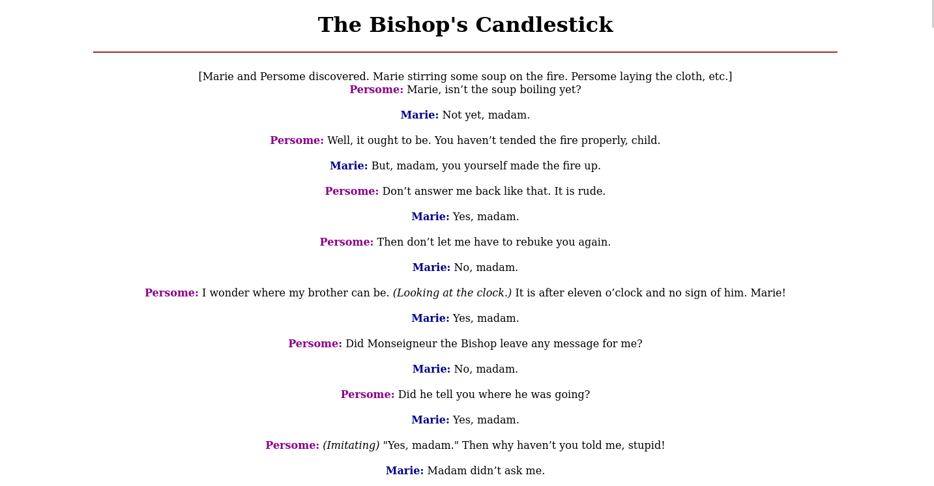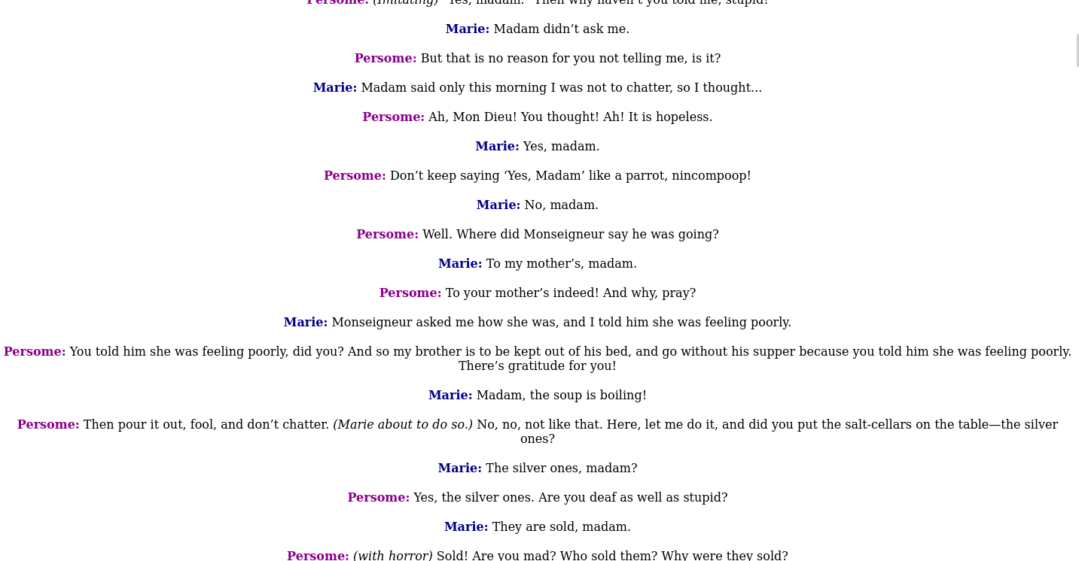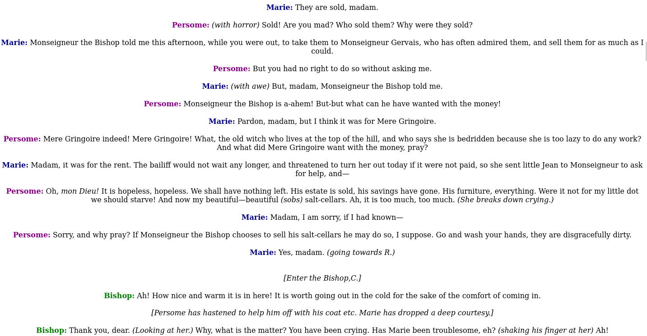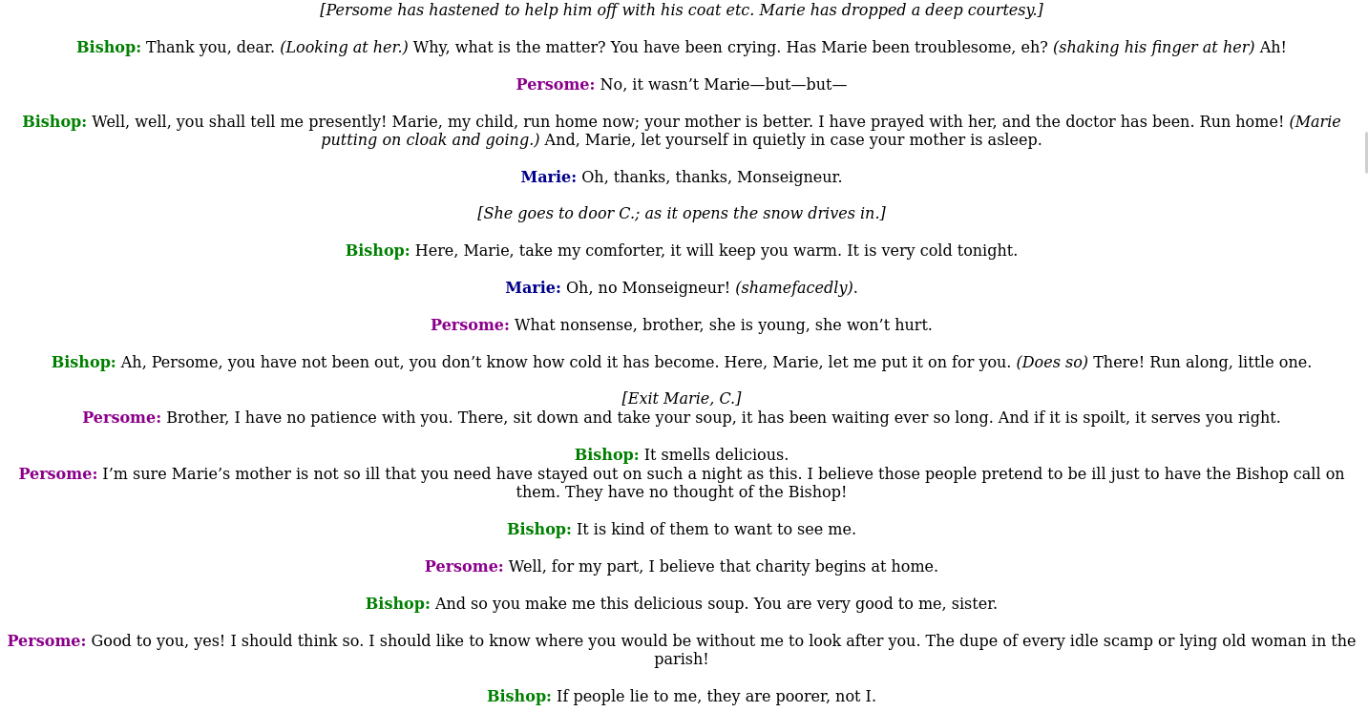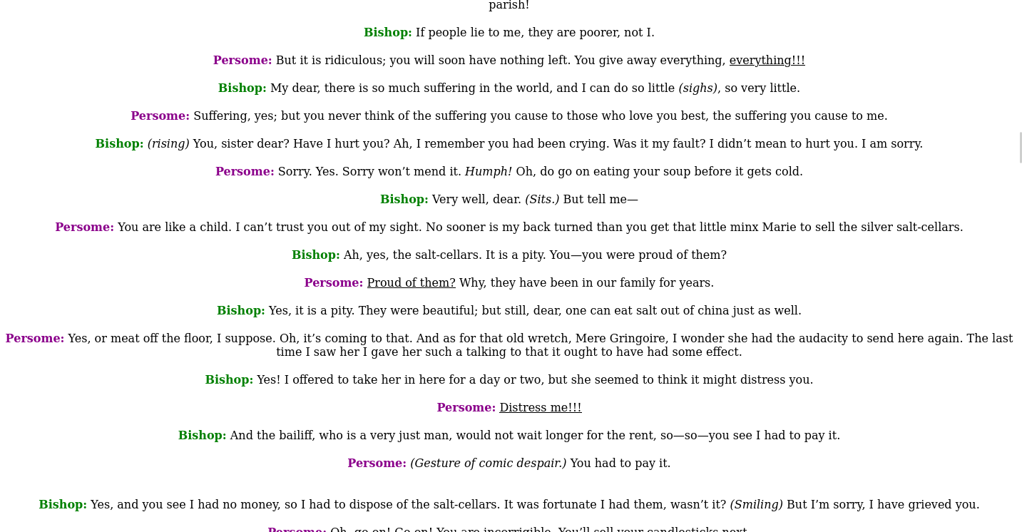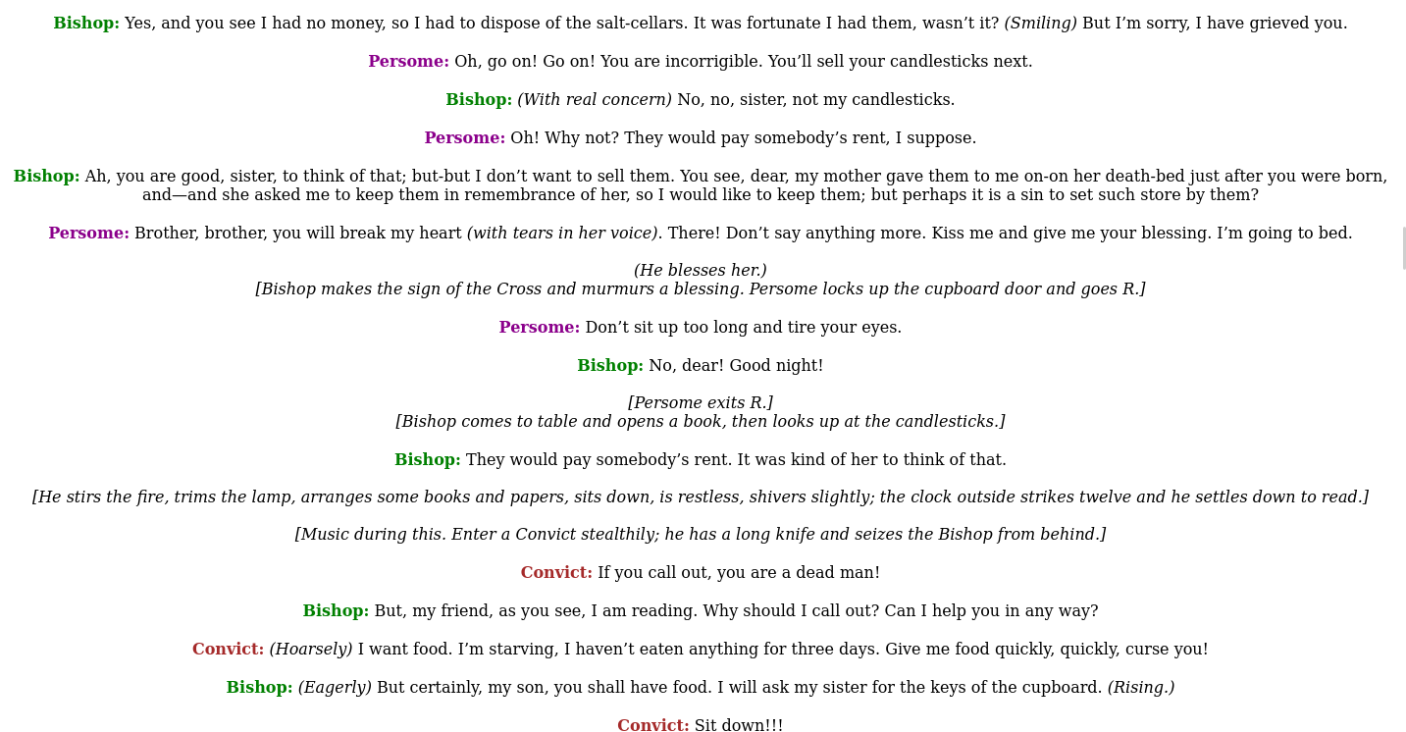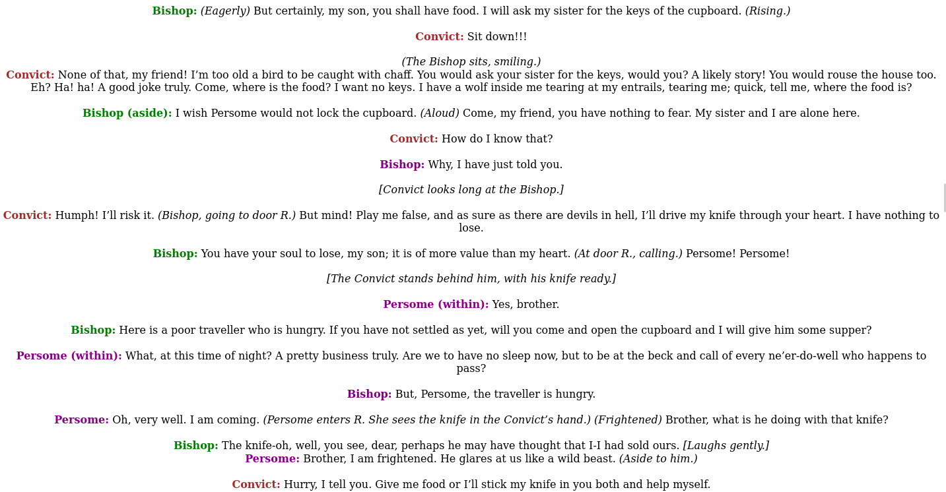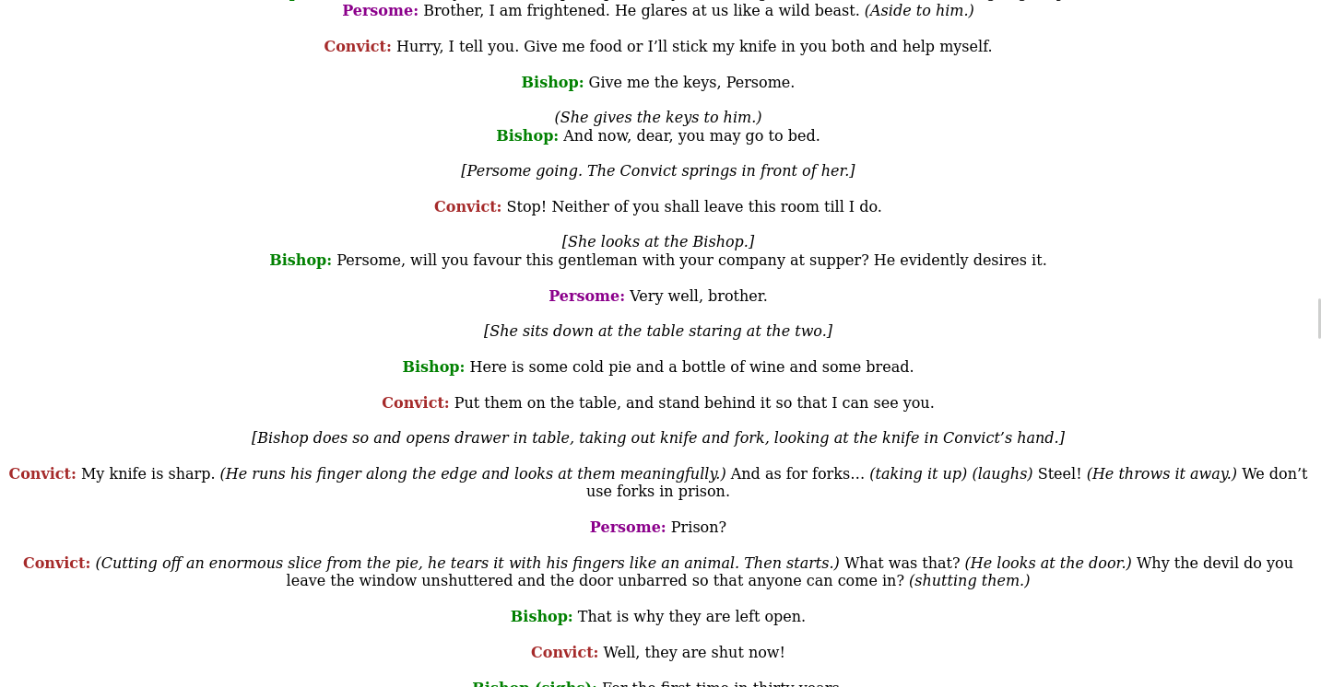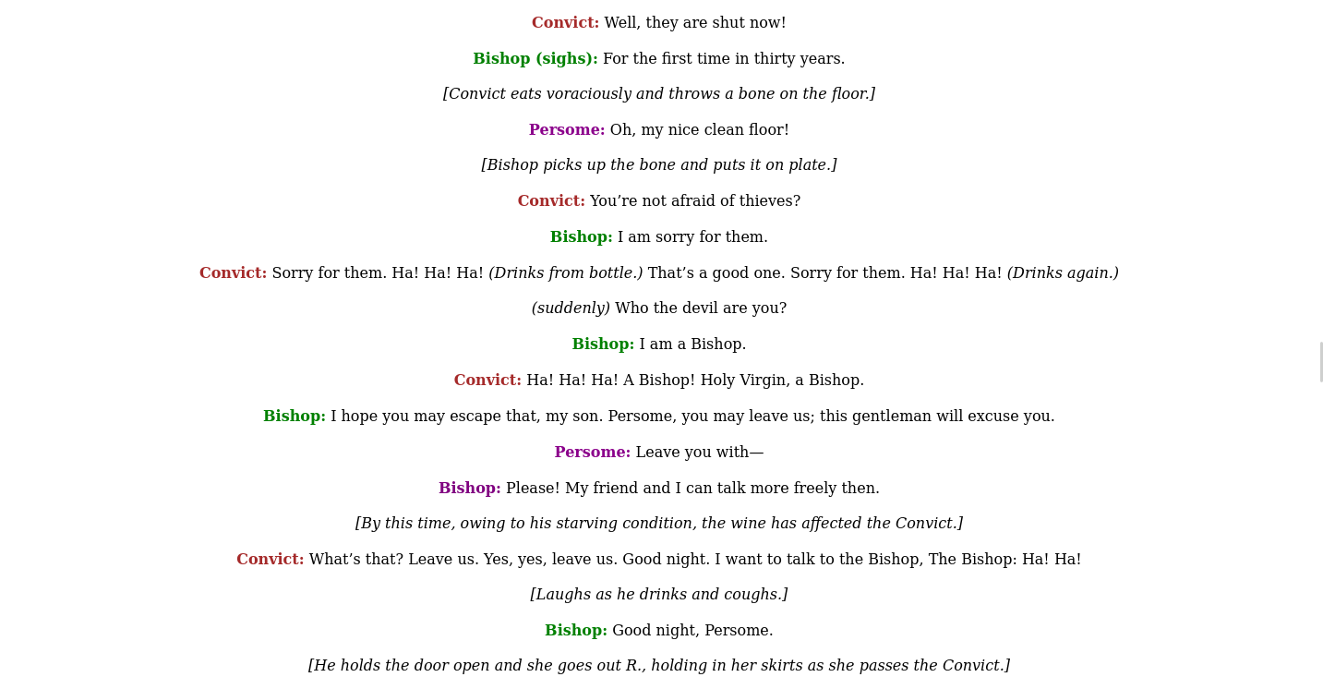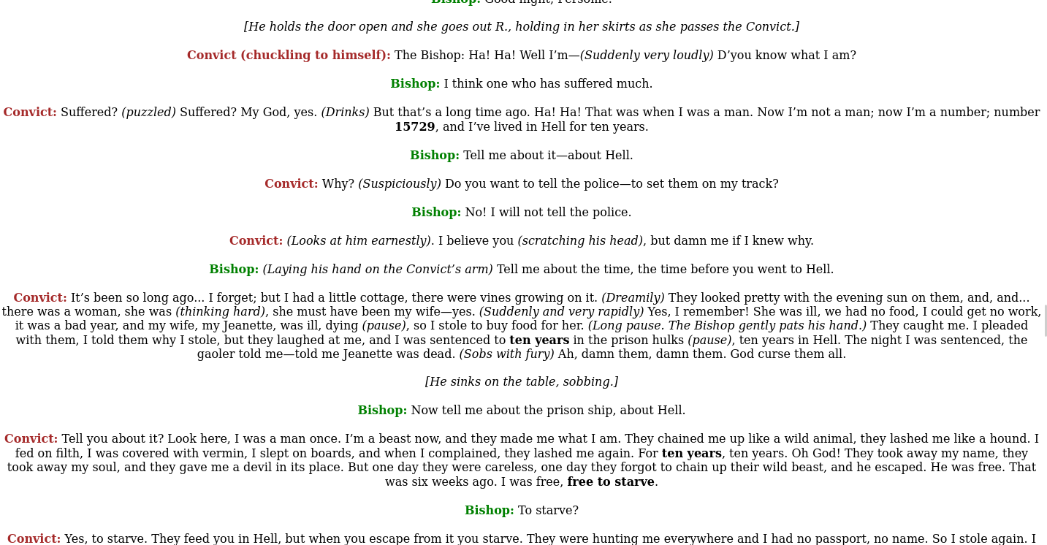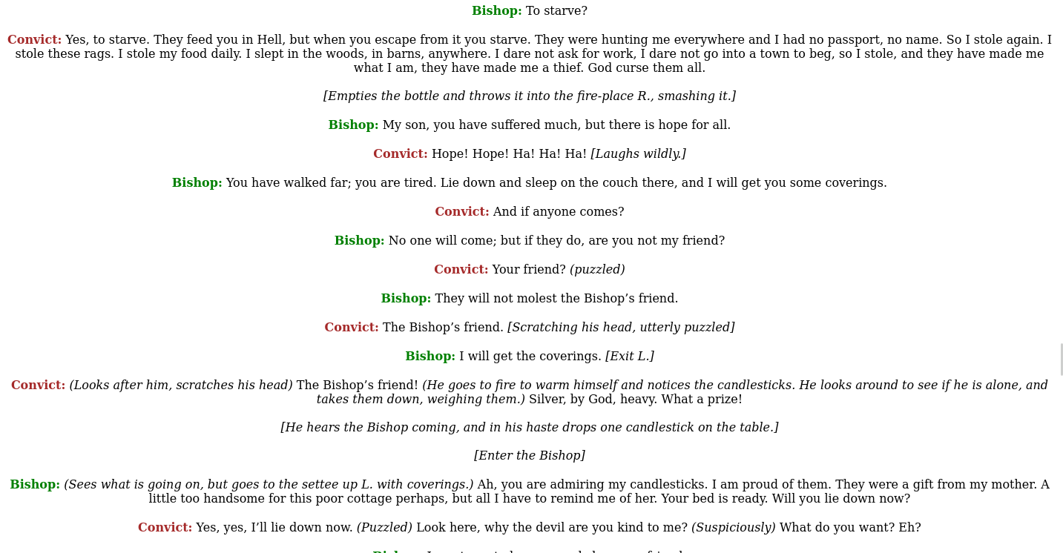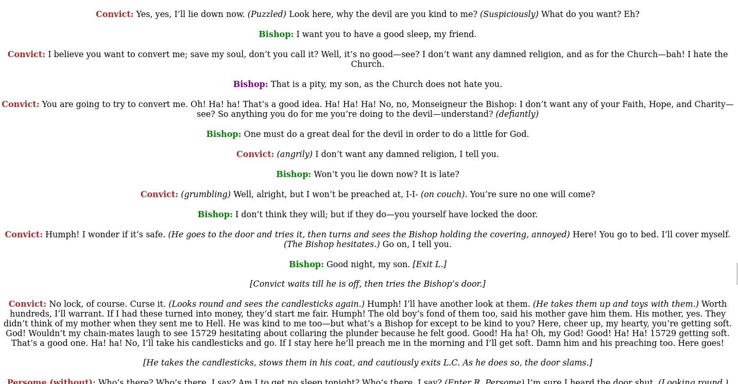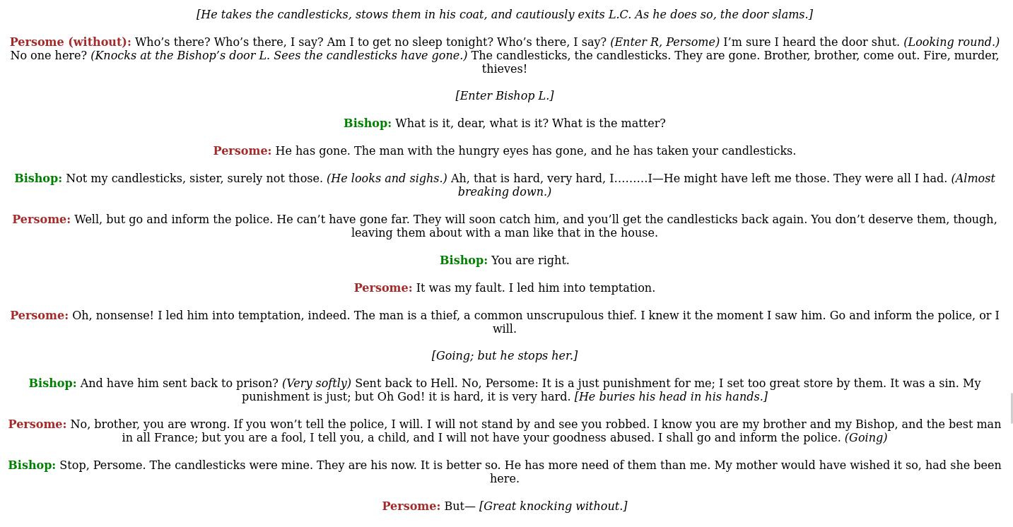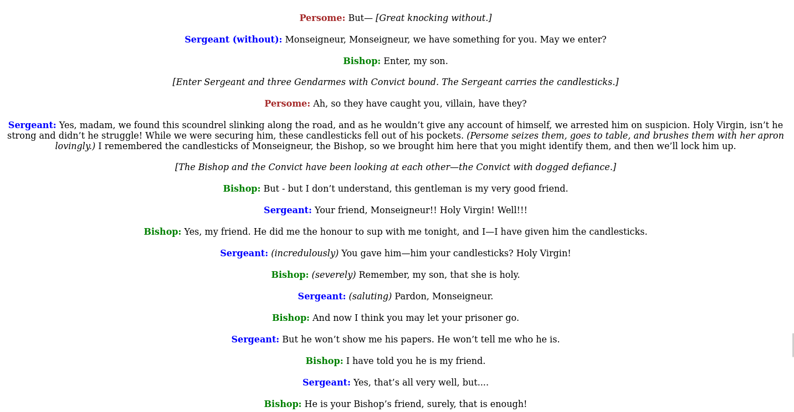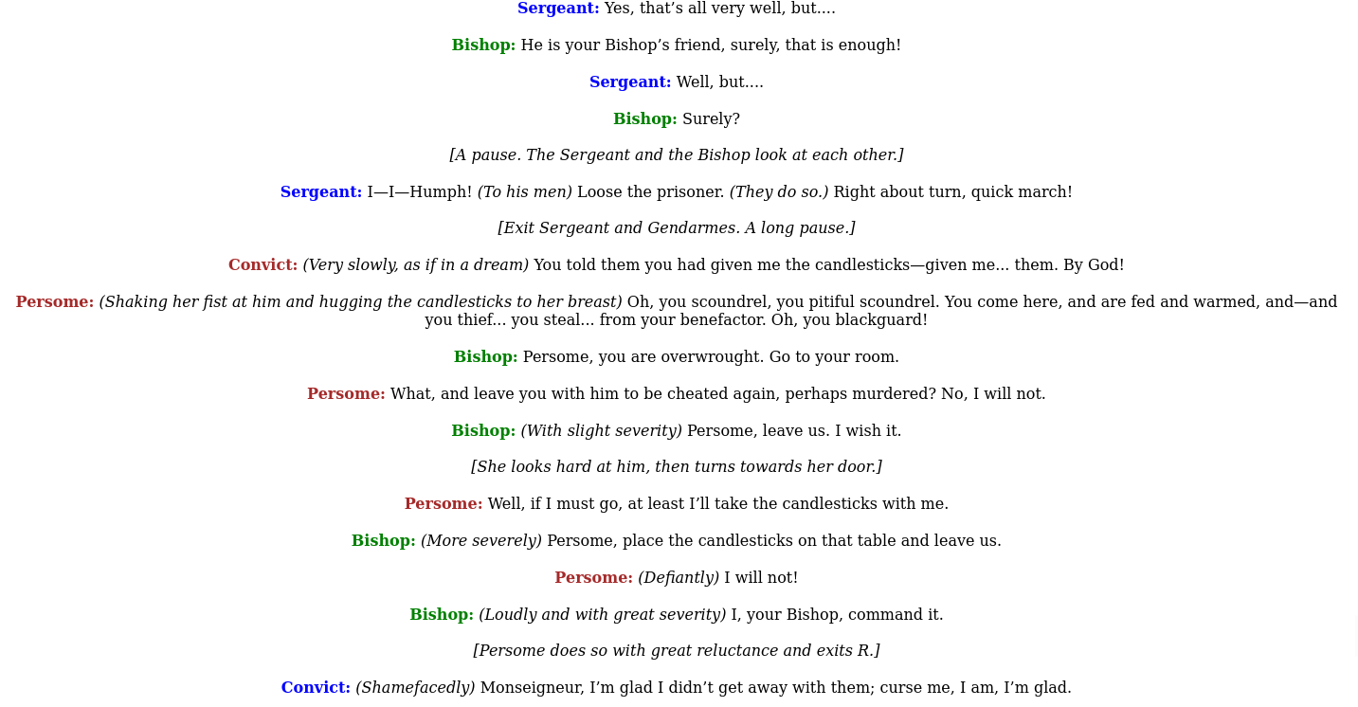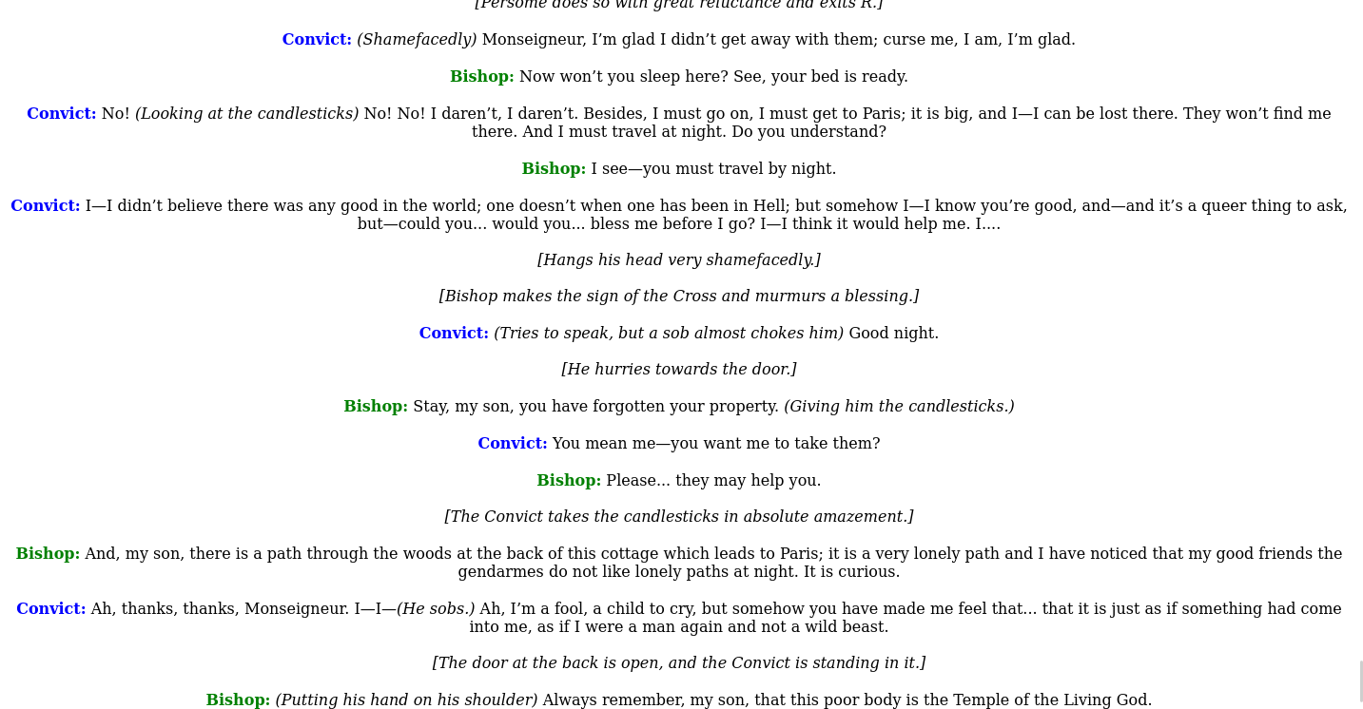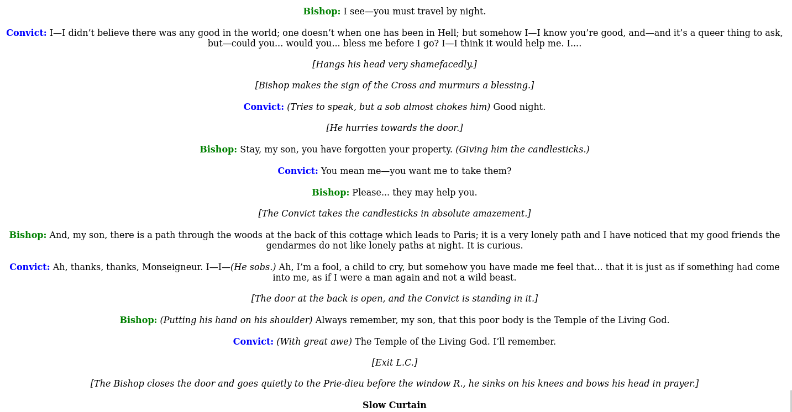

**Submitted by:**

**Abhinash Toijam**

**BC 1953**

**Sec: A**

**BCA 4th semester**